Senior Vocabulary 2.4
Write the correct vocabulary word under each picture that it represents. Then, write a sentence using the word based on the picture.
requisite replenish capricious manifest delve
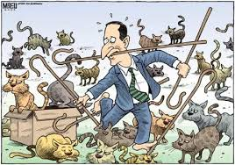

Vocabulary word: __________________________ Vocabulary word: __________________________
Sentence: ______________________________ Sentence: ______________________________
_________________________________________ _________________________________________
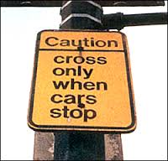
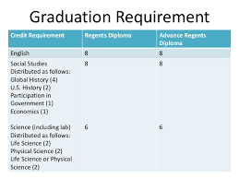

Vocabulary word: __________________________ Vocabulary word: __________________________
Sentence: ______________________________ Sentence: ______________________________
_________________________________________ __________________________________________

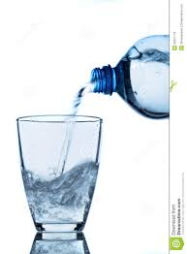

Vocabulary word: __________________________
Sentence: ______________________________
_________________________________________

