Senior Vocabulary 2.2
Write the correct vocabulary word under each picture that it represents. Then, write a sentence using the word based on the picture.
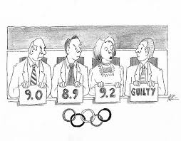
levity corroborate subjective placate insatiable

Vocabulary word: __________________________ Vocabulary word: __________________________
Sentence: ______________________________ Sentence: ______________________________
_________________________________________ _________________________________________
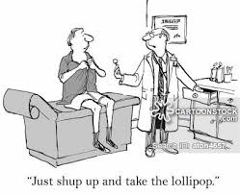

Vocabulary word: __________________________ Vocabulary word: __________________________
Sentence: ______________________________ Sentence: ______________________________
_________________________________________ __________________________________________

Vocabulary word: __________________________
Sentence: ______________________________
_________________________________________

