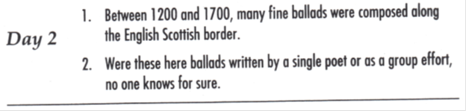

Hints: 1) Punctuation
2) Unnecessary word
Run-on sentence--correct in the following way: split into two separate sentences with
the correct ending punctuation for both and capitalization.

Corrected Sentences:

1)
2)

