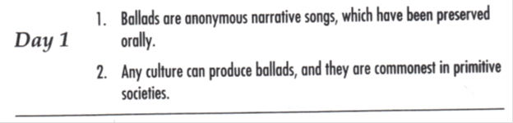
Hints: 1) incorrect relative pronoun (will also need to REMOVE punctuation)
2) incorrect coordinating conjunction; incorrect comparison form

Corrected Sentences:

1)
2)

